Appendix D: Equipment
ELECTROSTATIC PAPER AND ACCESSORIES:

To investigate electric fields with the electrostatic paper, you need to do the following:
• Lay the electrostatic paper flat. .
• Distribute the pieces of metal (called “electrodes”) on the paper, in the configuration whose field you wish to examine. The tips of the long brass rods may also be used as electrodes, to create point-like charges.
• Connect the electrodes to a source of charge. This is done by connecting a wire from the positive (“+”) side of the battery or power supply to one electrode and the wire from the negative (“–”) side to the other as shown in Figure 1.
• You may wish to place a wooden block on top of the brass rods to increase contact pressure with the paper. This can increase the magnitude of the electric field created on the paper. It also helps to place an extra sheet of paper under the electrostatic paper.

Figure 1: Electrostatic paper Setup Figure 2: Electric Field Probe
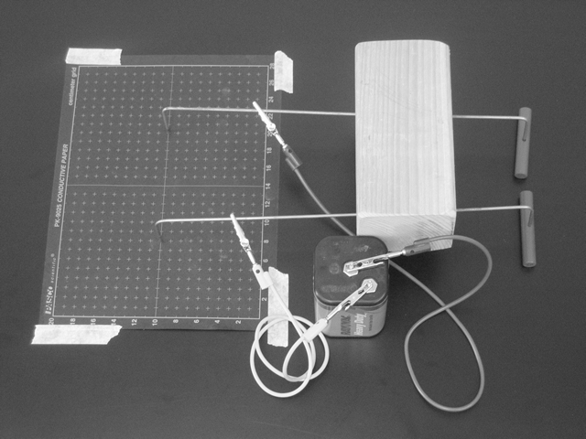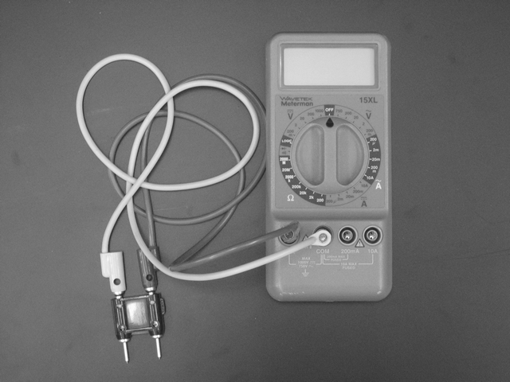
To measure the electric field from the charged electrodes, you will use a probe connected to a digital Multimeter set to measure volts (see Figure 2). For best results, turn the DMM to measure in the two-volt DC range, as indicated in Figure 2.

THE DIGITAL MULTIMETER (DMM)

The DMM is a common piece of lab equipment that can be used to measure various electrical quantities, most often current, resistance, and potential. The DMM’s you will be using are capable of measuring both “direct current” (DC) and “alternating current” (AC) circuits. Be careful about knowing which type of measurement you need to make, then set your DMM accordingly. Some DMM’s might be slightly different from the one pictured to the right. | 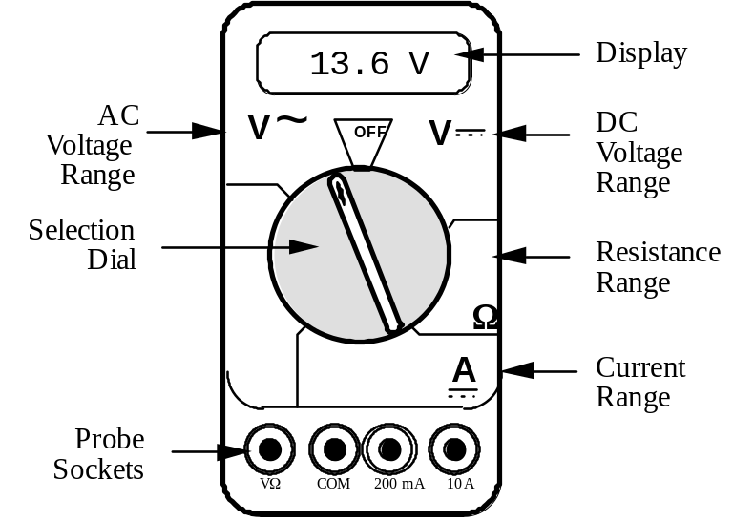

The DMM can measure currents anywhere from 10 amps to a microamp (10–6 amps). This versatility makes the DMM fragile, since measuring a large current while the DMM is prepared to measure a small one will certainly harm the DMM. For example, measuring a 1 ampere current while the DMM is on the 2 milliamp scale will definitely blow a fuse! If this happens, your instructor can change the fuse. However, if you damage the DMM beyond repair, you will have to finish the lab without the DMM.

Measuring Current:
1. Set the selection dial of the DMM to the highest current measurement setting (10 amps). Insert one wire into the socket labeled '10A' and a second wire into the socket labeled 'COM'.
2. Attach the DMM into the circuit as shown below:
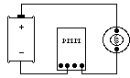
To measure current, the DMM must be placed in the circuit so that all the current you want to measure goes through the DMM.
3. If no number appears while the DMM is at the 10A setting, move the wire from the 10A socket to the 200mA socket and then turn the selection dial to the 200 milliamp (200m) setting. If there is still no reading, change the dial to the 20 milliamp setting, etc.
4. When you have taken your measurement, return the DMM selection dial to the highest current setting (10 amps) and move the wire back to the 10A socket.

Measuring Voltage:
1. Set the DMM selection dial to read DC volts (). Insert one wire into the socket labeled 'V?' and a second wire into the socket labeled 'COM'.
2. Set the selection dial of the DMM to the highest voltage measurement setting. Connect the two wires from the DMM to the two points between which you want to measure the voltage, as shown below.
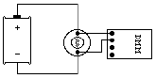
To measure voltage, the DMM must be placed in the circuit so that the potential difference across the circuit element you want to measure is across the DMM.
3. If no number appears, try a different measurement scale. Start at the highest voltage scale and work your way down the scales until you get a satisfactory reading.

Measuring Resistance:

The element whose resistance you are measuring must be free from all other currents (due to other batteries, power supplies, etc.) for the DMM to work. That means you must remove it from a circuit.

To measure resistance:
1. Set the DMM selection dial to measure ohms (Ω). Insert one wire into the socket labeled 'VΩ' and a second wire into the socket labeled 'COM'.
2. Make sure that the circuit element whose resistance you wish to measure is free of any currents.
3. Attach the wires across the circuit element, as shown in the example below.

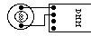

- If no number appears, try a different measurement scale. Use a logical method that covers all scales, such as beginning at the largest scale (20 MΩ) and working your way down.

CATHODE RAY TUBE (CRT) AND ACCESSORIES:

Use of the cathode-ray tube and its relatives is widespread. It is the heart of many familiar devices, from your computer monitor to your television. The following is a sketch of the tube you will be using and its connections.

Figure 3:  Cathode Ray Tube.  D = 7.4 cm  L = 2.0 cm  S = 0.30 cm  Dtot = 9.6 cm | 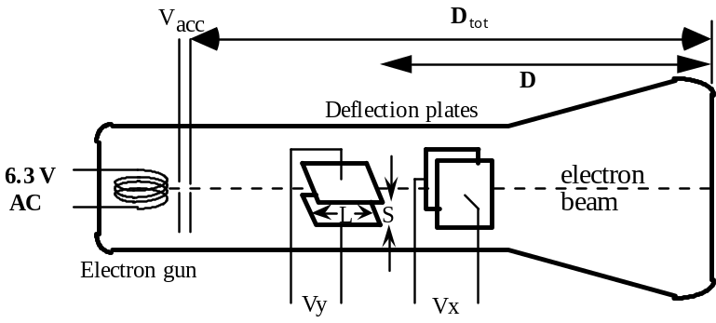

How the CRT works:
Within the electron gun:
• A thin filament (represented above as a coil of wire), similar to a light-bulb filament, is heated by a current. When the CRT is operating, this filament can be seen as an orange, glowing wire. This hot filament ejects slow-moving electrons.
• Some slow electrons drift toward the high-voltage “acceleration plates.” These plates are labeled as Vacc in Figure 3. The electric field between the charged plates accelerates the electrons to high velocities in the direction of the fluorescent screen. The final velocity of an accelerated electron is much greater than its initial “drift” velocity, so the initial electron velocity can be ignored in calculations.

After the electron gun:
• Before hitting the screen, the high-velocity electrons may be deflected by charged plates along the length of the CRT. These charged plates are usually called the “x-deflection” and “y-deflection” plates.
• When the electrons reach the end of the tube, their energy causes the material that coats the end of the tube to glow. This material is similar to the material inside fluorescent light bulbs. The end of the CRT is called the fluorescent screen.

To supply the necessary electric potentials to the CRT you will use a power supply. The power supply provided has the proper potential differences to heat the CRT filament and to accelerate the electrons. The power supplies we use also have built-in circuit breakers. Should you attempt to draw too much current from your power supply, it will shut itself off with an audible “click.” If this happens, check to make sure all of your wires are connected properly, then press in the small white button on the side of the power supply.

Note that the CRT and power supply come as a set, and many of the connections are color-coordinated to avoid potentially damaging misconnections. You will also have an assortment of batteries, which will be used to control the electric field between the CRT x- and y-deflection plates.

 | WARNING: You will be working with equipment that generates large electric voltages. Improper use can cause painful burns. To avoid danger, the power should be turned OFF and you should WAIT at least one minute before any wires are disconnected from or connected to the power supply.

To properly connect the CRT to the power supply:
1. Turn the power supply off.
2. Connect the power supply ports marked “AC 6.3V” (they are green; the voltage differs slightly from one supply to another, but should be clearly marked) to the ports marked “HEATER” or “FILAMENT” on the CRT (these are also green).
3. Connect the appropriate accelerating potential across the cathode and anode. For instance, if your experiment calls for a 500 volt accelerating potential, connect the cathode to the port marked “–250 V” (which may be black or white) and the anode to the port marked “+ 250 V” (which is red). This gives a total potential difference of 500 volts.
4. Turn the power supply on.

RESISTOR CODES

A resistor is a circuit element manufactured to have a constant resistance. The resistance is coded onto the side of the resistor in colored bands, where the color and position of the bands tell you what the resistance is.

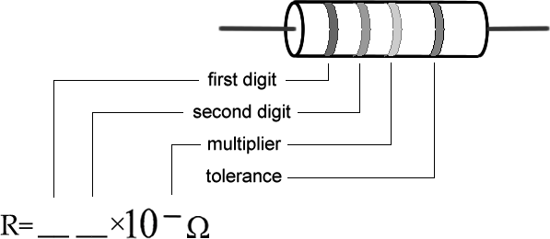

To read the color bands on the resistor, begin by finding the gold or silver band on one end of the resistor; this is the back of the resistor. You begin reading from the other end. Most resistors (including those you will use in lab) are coded to two significant digits. The first two color bands correspond to these two significant digits.

The third color band is called the multiplier. The number coded by this band represents a power of ten which you multiply by the number from the first two bands to get the total resistance.

The fourth color band tells you the tolerance, or error bounds for the coded resistance: gold means ±5% tolerance, silver means ±10% tolerance and no fourth band means ±20%.

Some resistors have a fifth color band, which represents the reliability of the resistor, and can just be ignored for the purposes of these labs.

Examples:  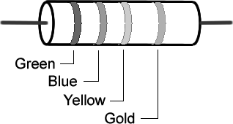  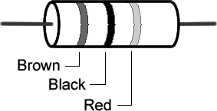  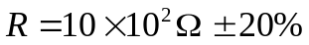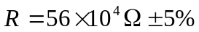 | Color | Number 9
 | Black  Brown  Red  Orange  Yellow  Green  Blue  Violet  Gray  White | 0  1  2  3  4  5  6  7  8  9

Sorensen Power Supplies

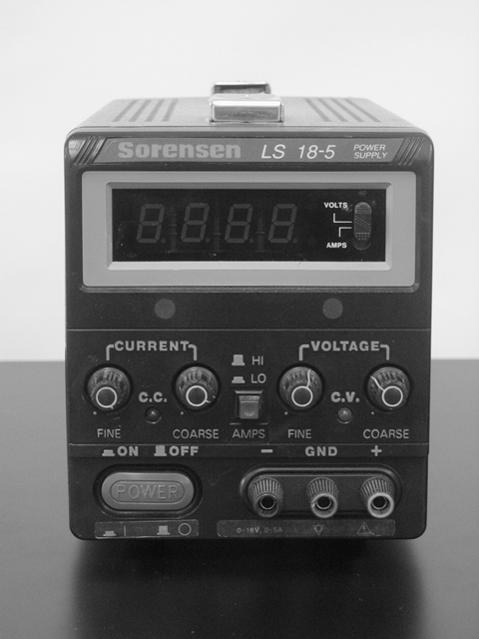
The Sorensen power supply is an all-purpose power supply for the production of constant currents and voltages.

At the top is the main display that reads either current in Amperes or voltage in Volts. There is a switch there that allows you to switch between them.

The current and voltage controls are located in the middle. In between the constant current and constant voltage knobs is a switch that allows you to toggle from high currents to low currents. It is highly recommended that you use only the low current mode.

This power supply normally operates in the constant voltage mode. As such, you can only change the voltages by using the constant voltage knobs. In the event that too much is being pulled from the power supply (as in a short), it will automatically switch to the constant current mode, where the amount of current flowing is greatly reduced. This is a signal that something is amiss with your circuit.

There is a mater-slave switch on the back of the power supply. This should always be set to master for the DMM to function properly. If you experience any problems, this is the first place to check.

THE MAGNETIC FIELD SENSOR (HALL PROBE)

To measure magnetic field strength, you will need a measurement probe (the magnetic field sensor) that connects to a computer through the Vernier LabPro lab interface..

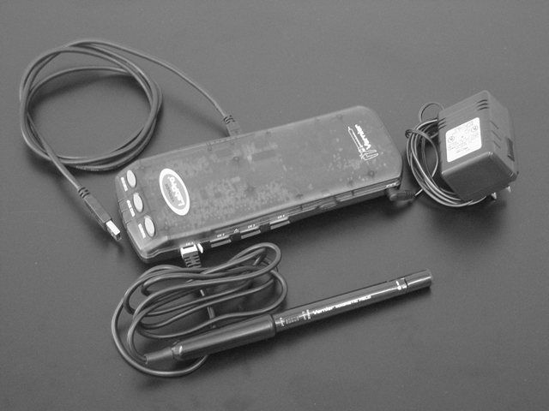

The tip of the measurement probe is embedded with a Hall Effect transducer chip (shown above as the white dot on the end of the probe). The chip produces a voltage that is linear with the magnetic field. The maximum output of the chip occurs when the plane of the white dot on the sensor is perpendicular to the direction of the magnetic field, as shown below:

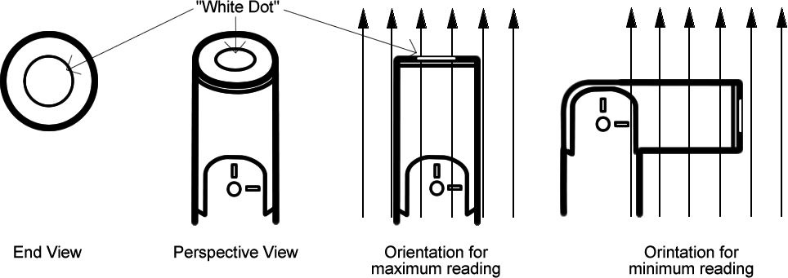

The LabPro allows the computer to communicate with the probe. In order to measure magnetic fields, the wire leading out of the probe must be plugged into the LabPro port labeled "CH 1". The LabPro itself should be plugged into the modem port of the computer. The LabPro turns on automatically when its power supply is plugged in. A green light on the top of the LabPro indicates that it is on.

The Range switch on the side of the probe is to allow you to measure a greater range of magnetic field strengths. Each setting represents the maximum field strength that the probe can measure: either ±6.4mT or ±0.3mT. When measuring stronger magnetic fields, you should use the 6.4mT setting, but for fields weaker than 0.3mT the lower setting will give you a more accurate reading.

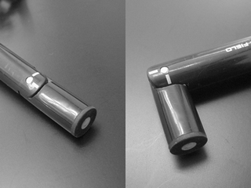

The measurement probes have swiveling tips to allow for more convenient data collection. Note: that these tips are only meant to swivel in one direction. They will break of they are bent in the other direction, and they are very fragile, so it does not take much to do this. Please be very careful as these are costly to replace.

MEASURING RADIATION
(Geiger Counter)

To measure radiation you will need a Geiger Counter. The tube detects incoming radiation (alpha, beta, or gamma decay) and produces a voltage spike which the counter unit records. To use the Geiger Counter in conjunction with the computer plug the connecting cord into the round hole on the right side of the counter, and plug the other end of the connecting cord into the LabPro Interface port labeled “DIG/SONIC 1”. The computer uses the software LoggerPro in conjunction with the Geiger Counter to measure radiation. For a description of the LoggerPro software see Appendix E.

To begin measuring radiation amounts the power switch on the Geiger Counter must be moved to the “ON” position, or the “AUDIO” position. The Geiger Counter’s red light will flash whenever it makes a radiation count. When in the “AUDIO” position the counter will also make a beep noise whenever it makes a radiation count.

There is a switch on the Geiger Counter that controls its detection sensitivity. The switch has positions labeled 1X, 10X, etc. For the lab problems in this manual the 1X position will most likely be the best setting.

Counts recorded by the detector are the result of radioactive decay, which is a randomly occurring event. Events that are the result of random processes have inherent uncertainty. This means that if the count rate for a certain sample is recorded several times, the number of counts recorded will fluctuate around an average. In a set of N counts, if N is small the uncertainty in N will follow Poisson Statistics. If N is large the uncertainty will follow Gaussian Statistics. (These terms are explained in any math reference book, for example see http://mathworld.wri.com). Keep uncertainty in mind when deciding how many counts are "enough" to allow comparisons among count rates under different conditions.

